AWS CLOUD
Documentation & Implementation Guide
─────────────────────────────────────────
Production-Style 3-Tier Architecture
Domain: medishift.co.in
Architecture Covered
VPC • Subnets • IGW • NAT Gateway • Route Tables
Security Groups • EC2 • ALB • Auto Scaling • Route53 • ACM
Multi-AZ • High Availability • HTTPS • DNS • Bastion Host

Table of Contents
The following chapters are covered in this document:

- Chapter 1: Introduction to Cloud Computing
- Chapter 2: Introduction to Amazon Web Services (AWS)
- Chapter 3: VPC — Virtual Private Cloud
- Chapter 4: Subnets — Network Segmentation
- Chapter 5: Internet Gateway
- Chapter 6: NAT Gateway
- Chapter 7: Elastic IP Addresses
- Chapter 8: Route Tables
- Chapter 9: Security Groups — Layered Security
- Chapter 10: EC2 — Elastic Compute Cloud
- Chapter 11: Bastion Host — Secure Administrative Access
- Chapter 12: Application Deployment Architecture
- Chapter 13: User Data Scripts
- Chapter 14: Target Groups
- Chapter 15: Application Load Balancer (ALB)
- Chapter 16: ALB Routing Types
- Chapter 17: Auto Scaling
- Chapter 18: ACM — AWS Certificate Manager
- Chapter 19: Route53 — DNS Management
- Chapter 20: Route53 Routing Policies
- Chapter 21: Complete HTTPS Architecture
- Chapter 22: High Availability Architecture
- Chapter 23: Scalability Architecture
- Chapter 24: End-to-End 3-Tier Application Flow
- Chapter 25: Security Architecture Summary
- Chapter 26: Quick Reference

Chapter 1: Introduction to Cloud Computing

1.1 The Traditional Infrastructure Problem
Before cloud computing existed, every company that needed to run software had to build and maintain their own physical infrastructure. This meant purchasing servers, networking equipment, storage devices, and cooling systems — all of which required significant capital investment, physical space, and dedicated IT staff to manage.

Real-World Problem Example
Imagine you are launching an e-commerce website. In the traditional model:

• You must buy physical servers weeks or months before launch
• You must estimate peak traffic accurately (Black Friday, sales events)
• If you underestimate, your site crashes during peak periods
• If you overestimate, you waste money on idle hardware
• You must hire staff to maintain servers 24/7/365
• Hardware failures cause extended downtime
• Scaling up requires ordering, shipping, and installing new hardware — weeks of lead time

Core Problems with Traditional Infrastructure
Problem | Business Impact
High Capital Expenditure (CapEx) | Millions invested upfront before any revenue is generated
Long Provisioning Time | Weeks or months to get new infrastructure running
Fixed Capacity | Cannot scale up or down quickly based on demand
Hardware Failure Risk | Single points of failure cause complete outages
Geographic Limitations | Cannot easily serve global users with low latency
Maintenance Overhead | Large IT teams needed for patches, upgrades, failures
Underutilization | Average server utilization in traditional DCs is only 10-15%
Disaster Recovery Complexity | Building DR sites is expensive and complex

1.2 What is Cloud Computing?
Cloud computing is the delivery of computing services — including servers, storage, databases, networking, software, analytics, and intelligence — over the internet ("the cloud") to offer faster innovation, flexible resources, and economies of scale.
In simple terms: Instead of owning and managing your own servers and data centers, you rent computing resources from a cloud provider (like AWS) and pay only for what you use, when you use it.
Simple Analogy
Think of cloud computing like electricity from the power grid:

• You do not build your own power plant to get electricity
• You plug into the power grid and pay for what you consume
• The power company handles generation, maintenance, and reliability
• You can use as much or as little as you need

Cloud computing works the same way — for computing resources.

1.3 Key Advantages of Cloud Computing

1.3.1 Scalability
Scalability is the ability to increase your infrastructure capacity to handle more load. In the cloud, you can add more servers within minutes to handle increased traffic, then remove them when the traffic drops.
- Vertical Scaling (Scale Up): Increase the size of an existing server (more CPU, RAM)
- Horizontal Scaling (Scale Out): Add more servers to distribute the load
- AWS Example: Auto Scaling Groups automatically add EC2 instances when CPU usage exceeds a threshold

1.3.2 Elasticity
Elasticity goes beyond scalability. Elastic infrastructure automatically scales up when demand increases AND automatically scales back down when demand decreases — without human intervention.
Elasticity Example
Netflix Experience:
• 3:00 PM (low traffic): 100 servers running
• 8:00 PM (peak streaming): Auto-scale to 1,000 servers
• 11:00 PM (traffic drops): Auto-scale back to 200 servers

Netflix pays only for the resources used at each point in time.
This is true cloud elasticity.

1.3.3 High Availability (HA)
High Availability means your application remains accessible and operational even when individual components fail. Cloud providers like AWS build redundancy at every level — data centers, power supplies, network connections, and hardware.
- HA is achieved through redundancy: having multiple copies of every component
- If one server fails, traffic automatically routes to healthy servers
- AWS deploys resources across multiple Availability Zones to eliminate single points of failure
- Target: 99.99% uptime = less than 52 minutes of downtime per year

1.3.4 Fault Tolerance
Fault tolerance is the ability of a system to continue operating correctly even when one or more components fail. Unlike high availability (which minimizes downtime), fault-tolerant systems may have zero downtime during failures.
- Built-in redundancy at hardware, network, and software layers
- Automatic failover mechanisms transfer load instantly when failures occur
- Data is replicated across multiple locations to prevent data loss

1.3.5 Pay-As-You-Go Model
One of the most significant advantages of cloud computing is the shift from Capital Expenditure (CapEx) to Operational Expenditure (OpEx). You pay only for the computing resources you actually use.
Traditional (CapEx) Model | Cloud (OpEx) Model
Buy servers upfront | Pay per hour/minute of use
Fixed cost regardless of usage | Variable cost — scales with usage
Long procurement cycles | Instant provisioning
Depreciation over years | No asset depreciation
Overprovisioning is common | Right-size at any time
High minimum investment | Start with $0 upfront

1.3.6 Global Reach
Cloud providers operate data centers in dozens of geographic regions worldwide. This allows companies to deploy their applications close to their end users, resulting in lower latency and better user experience.

1.4 The AWS Shared Responsibility Model
Security in the cloud is a shared responsibility between AWS and the customer. Understanding this boundary is critical for building secure applications.

Shared Responsibility Model
AWS IS RESPONSIBLE FOR ("Security OF the Cloud"):
• Physical data center security
• Hardware and infrastructure maintenance
• Network infrastructure
• Hypervisor and virtualization layer
• Global infrastructure (Regions, AZs, Edge Locations)

CUSTOMER IS RESPONSIBLE FOR ("Security IN the Cloud"):
• Operating system patches and updates
• Application security and code
• Data encryption (in transit and at rest)
• Identity and Access Management (IAM)
• Network configuration (VPC, Security Groups, NACLs)
• Customer data and its classification

1.5 Why Enterprises Move to Cloud
- Cost Optimization: Eliminate large upfront hardware investments
- Speed and Agility: Launch new infrastructure in minutes instead of weeks
- Innovation: Access to 200+ managed services to build modern applications
- Global Expansion: Deploy in new regions instantly without physical presence
- Disaster Recovery: Built-in multi-region backup and recovery capabilities
- Security: Benefit from AWS's massive security investment and compliance certifications
- Focus: Let AWS manage infrastructure so teams can focus on business logic

Chapter 2: Introduction to Amazon Web Services (AWS)

2.1 What is AWS?
Amazon Web Services (AWS) is a comprehensive and broadly adopted cloud platform, offering over 200 fully featured services from data centers globally. AWS was launched in 2006 and has since become the world's most comprehensive and widely adopted cloud platform.

AWS serves millions of customers — from fast-growing startups to the world's largest enterprises and leading government agencies — to lower costs, become more agile, and innovate faster.

2.2 AWS Global Infrastructure
AWS operates one of the largest, most resilient, and most reliable global cloud infrastructures in the world. Understanding the AWS global infrastructure is essential for building highly available and performant applications.

2.2.1 AWS Regions
An AWS Region is a physical location in the world where AWS has multiple data centers. Each AWS Region consists of multiple, isolated, and physically separate Availability Zones within a geographic area.

Key Facts About AWS Regions
• As of 2024, AWS operates 33+ geographic Regions worldwide
• Each Region is completely independent of other Regions
• Data does NOT automatically replicate across Regions
• You choose which Region to deploy your resources in
• Regions have unique identifiers: us-east-1, eu-west-1, ap-southeast-1, etc.

Example Regions:
us-east-1 = US East (N. Virginia) ← Most popular Region
us-east-2 = US East (Ohio)
eu-west-1 = Europe (Ireland)
ap-south-1 = Asia Pacific (Mumbai)
ap-southeast-1 = Asia Pacific (Singapore)

How to Choose the Right AWS Region
- Compliance: Does data need to remain in a specific country (GDPR, data sovereignty)?
- Latency: Choose the Region closest to your end users for best performance
- Availability: Not all services are available in all Regions
- Cost: Pricing varies slightly between Regions

2.2.2 Availability Zones (AZs)
An Availability Zone (AZ) is one or more discrete data centers with redundant power, networking, and connectivity within an AWS Region. AZs are physically separated from each other — typically miles apart — but connected through low-latency, high-bandwidth, highly redundant network links.

Why AZs Matter for Your Architecture
Each AZ is a completely independent facility:
• Separate power sources (different power grids)
• Separate networking infrastructure
• Separate physical buildings
• Connected to other AZs in same Region with ultra-fast links

This means:
If AZ-a floods, burns, or loses power → AZ-b is completely unaffected
Your application in AZ-b continues serving users without interruption

AZ Naming Convention:
us-east-1a = First AZ in us-east-1 Region
us-east-1b = Second AZ in us-east-1 Region
us-east-1c = Third AZ in us-east-1 Region

2.2.3 Edge Locations
Edge Locations are AWS infrastructure endpoints for content delivery (Amazon CloudFront) and DNS resolution (Route53). They are located in more cities than Regions and AZs, putting AWS infrastructure close to end users worldwide.
- AWS has 400+ Edge Locations globally
- Route53 uses edge locations for fast DNS resolution worldwide
- Edge locations cache content closer to users for lower latency

2.3 AWS Global Infrastructure Diagram

AWS Global Infrastructure Overview
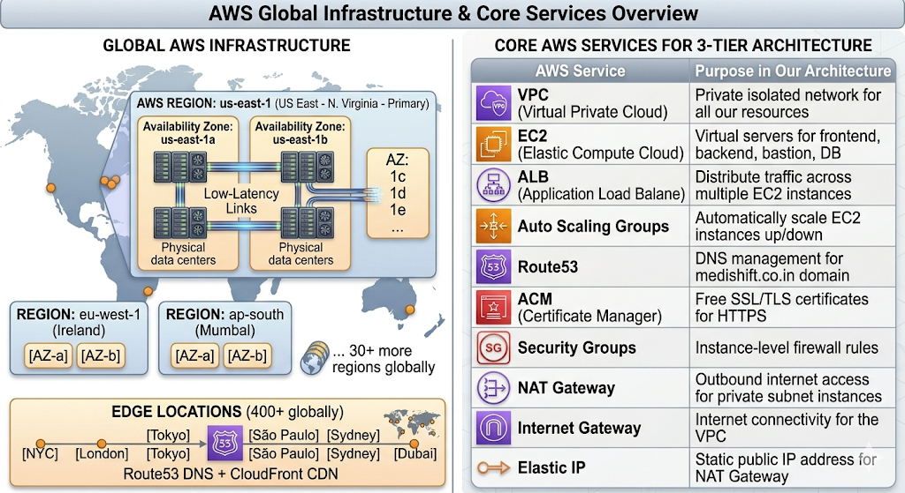

2.4 Core AWS Services Overview
AWS offers over 200 services. This documentation focuses on the networking and compute services used to build our 3-tier architecture. Here is a high-level overview:
AWS Service | Purpose in Our Architecture
VPC (Virtual Private Cloud) | Private isolated network for all our resources
EC2 (Elastic Compute Cloud) | Virtual servers for frontend, backend, bastion, DB
ALB (Application Load Balancer) | Distribute traffic across multiple EC2 instances
Auto Scaling Groups | Automatically scale EC2 instances up/down
Route53 | DNS management for medishift.co.in domain
ACM (Certificate Manager) | Free SSL/TLS certificates for HTTPS
Security Groups | Instance-level firewall rules
NAT Gateway | Outbound internet access for private subnet instances
Internet Gateway | Internet connectivity for the VPC
Elastic IP | Static public IP address for NAT Gateway
Chapter 3: VPC — Virtual Private Cloud

3.1 What is a VPC?
A Virtual Private Cloud (VPC) is your own private, logically isolated section of the AWS Cloud where you can launch AWS resources in a virtual network that you define. Think of a VPC as your own private data center inside AWS — completely isolated from other AWS customers.

VPC Definition in Simple Terms
When you create an AWS account, AWS gives you a Default VPC.
For production environments, you ALWAYS create a Custom VPC.

A VPC is like a private fenced compound inside AWS:
• You control what comes in (inbound traffic)
• You control what goes out (outbound traffic)
• Resources inside can communicate with each other privately
• Resources outside cannot access your VPC unless you allow them
• You define the IP address range (CIDR block)
• You divide it into subnets (smaller network segments)

3.2 Why VPC is Needed
- Network Isolation: Your resources are isolated from other AWS customers
- Security Control: You define exactly what traffic is allowed
- Custom IP Addressing: Choose your own private IP ranges
- Subnet Segmentation: Separate public and private components
- Compliance: Meet regulatory requirements for network isolation
- Cost Control: Private communication between resources avoids internet charges

3.3 CIDR Block Planning
CIDR (Classless Inter-Domain Routing) is the notation used to define a range of IP addresses. For our architecture, we use 10.0.0.0/16 as our VPC CIDR block.

Understanding CIDR Notation: 10.0.0.0/16
10.0.0.0/16 means:
• Network portion: first 16 bits = 10.0.x.x
• Host portion: last 16 bits = x.x.0.0 to x.x.255.255
• Total IP addresses: 2^16 = 65,536 IP addresses
• Range: 10.0.0.0 to 10.0.255.255

Our 8 Subnet Allocations within 10.0.0.0/16:
Public Subnet 1 (us-east-1a): 10.0.1.0/24 → 256 IPs
Public Subnet 2 (us-east-1b): 10.0.2.0/24 → 256 IPs
Frontend Subnet 1 (us-east-1a): 10.0.3.0/24 → 256 IPs
Frontend Subnet 2 (us-east-1b): 10.0.4.0/24 → 256 IPs
Backend Subnet 1 (us-east-1a): 10.0.5.0/24 → 256 IPs
Backend Subnet 2 (us-east-1b): 10.0.6.0/24 → 256 IPs
DB Subnet 1 (us-east-1a): 10.0.7.0/24 → 256 IPs
DB Subnet 2 (us-east-1b): 10.0.8.0/24 → 256 IPs

3.4 Creating Your VPC — AWS Console Steps
Follow these exact steps to create the custom VPC for our architecture:
- Navigate to AWS Console → Services → VPC
- Click "Your VPCs" in the left navigation panel
- Click "Create VPC" button (orange button, top right)
- Select "VPC only" (not VPC and more)
- Name tag: Enter "Production-VPC" or "medishift-vpc"
- IPv4 CIDR block: Enter 10.0.0.0/16
- IPv6 CIDR block: Select "No IPv6 CIDR block"
- Tenancy: Select "Default"
- Click "Create VPC"

Post-Creation Verification
After creating the VPC, verify:
✓ VPC appears in "Your VPCs" list
✓ State shows "Available"
✓ CIDR shows 10.0.0.0/16
✓ DNS resolution: Enabled
✓ DNS hostnames: Enable this! (Actions → Edit VPC settings → Enable DNS hostnames)

Chapter 4: Subnets — Network Segmentation

4.1 What is a Subnet?
A subnet (subnetwork) is a smaller, segmented portion of your VPC's IP address space. Subnets allow you to divide your VPC into multiple segments, each serving a specific purpose and having different security and routing configurations.

Every EC2 instance, load balancer, and database in your VPC must be placed in a specific subnet. The subnet determines the instance's IP address range, routing behavior, and internet access capabilities.

4.2 Public vs. Private Subnets
Public Subnet | Private Subnet
Has a route to Internet Gateway | No route to Internet Gateway
Resources CAN have public IPs | Resources CANNOT have public IPs
Directly accessible from internet | NOT directly accessible from internet
Used for: Bastion hosts, Load balancers, NAT GW | Used for: App servers, databases, internal services
Higher security risk if misconfigured | Naturally protected from direct internet access

4.3 Our 3-Tier Subnet Architecture
Our architecture uses 8 subnets spread across 2 Availability Zones to achieve both security isolation and high availability:

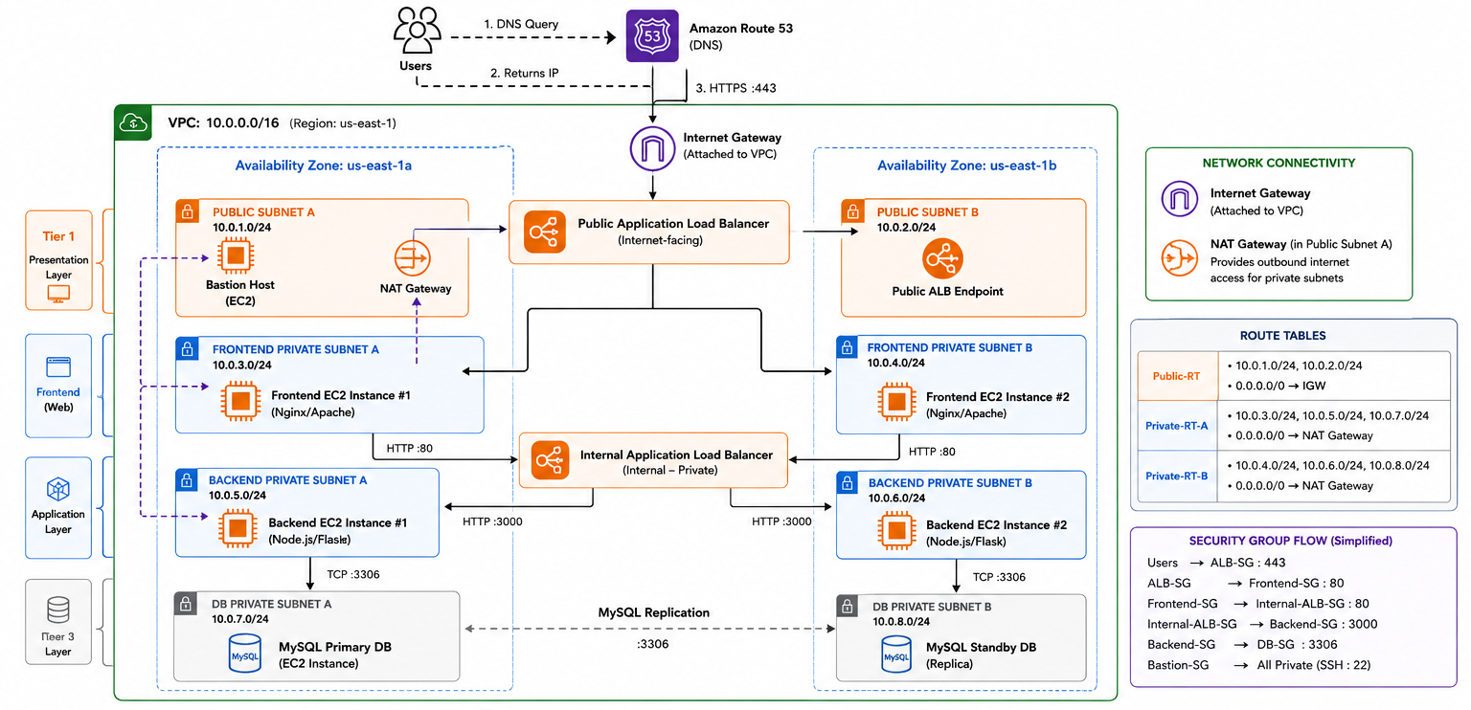

4.4 Creating Subnets — AWS Console Steps
Create all 8 subnets using these steps. Repeat for each subnet:

- Go to VPC Console → Subnets → Create Subnet
- VPC ID: Select your Production-VPC
- Subnet name: Use descriptive names (e.g., "Public-Subnet-1a")
- Availability Zone: Select the correct AZ (us-east-1a or us-east-1b)
- IPv4 CIDR block: Enter the subnet CIDR from the table below
- Click "Add new subnet" to add multiple subnets at once
- Click "Create subnet" when all 8 are configured

Subnet Name | CIDR Block | Avail. Zone | Type
Public-Subnet-1a | 10.0.1.0/24 | us-east-1a | Public
Public-Subnet-1b | 10.0.2.0/24 | us-east-1b | Public
Frontend-Subnet-1a | 10.0.3.0/24 | us-east-1a | Private
Frontend-Subnet-1b | 10.0.4.0/24 | us-east-1b | Private
Backend-Subnet-1a | 10.0.5.0/24 | us-east-1a | Private
Backend-Subnet-1b | 10.0.6.0/24 | us-east-1b | Private
DB-Subnet-1a | 10.0.7.0/24 | us-east-1a | Private
DB-Subnet-1b | 10.0.8.0/24 | us-east-1b | Private

Enable Auto-Assign Public IP for Public Subnets
For Public-Subnet-1a and Public-Subnet-1b, enable auto-assign public IP:
- Select the public subnet → Actions → Edit subnet settings
- Check "Enable auto-assign public IPv4 address"
- Click Save
This ensures EC2 instances launched in public subnets automatically get public IP addresses.

Chapter 5: Internet Gateway

5.1 What is an Internet Gateway?
An Internet Gateway (IGW) is a horizontally scaled, redundant, and highly available VPC component that enables communication between instances in your VPC and the internet. It serves two purposes: providing a target in your VPC route tables for internet-routable traffic, and performing network address translation (NAT) for instances assigned public IPv4 addresses.

5.2 Why Internet Gateway is Needed
- Without an IGW, your VPC is completely isolated — no internet connectivity at all
- The IGW is the "door" that connects your VPC to the public internet
- Public subnets use the IGW to allow both inbound and outbound internet traffic
- One IGW per VPC — it is already highly available and redundant (managed by AWS)

5.3 IGW Traffic Flow
Internet Gateway Traffic Flow
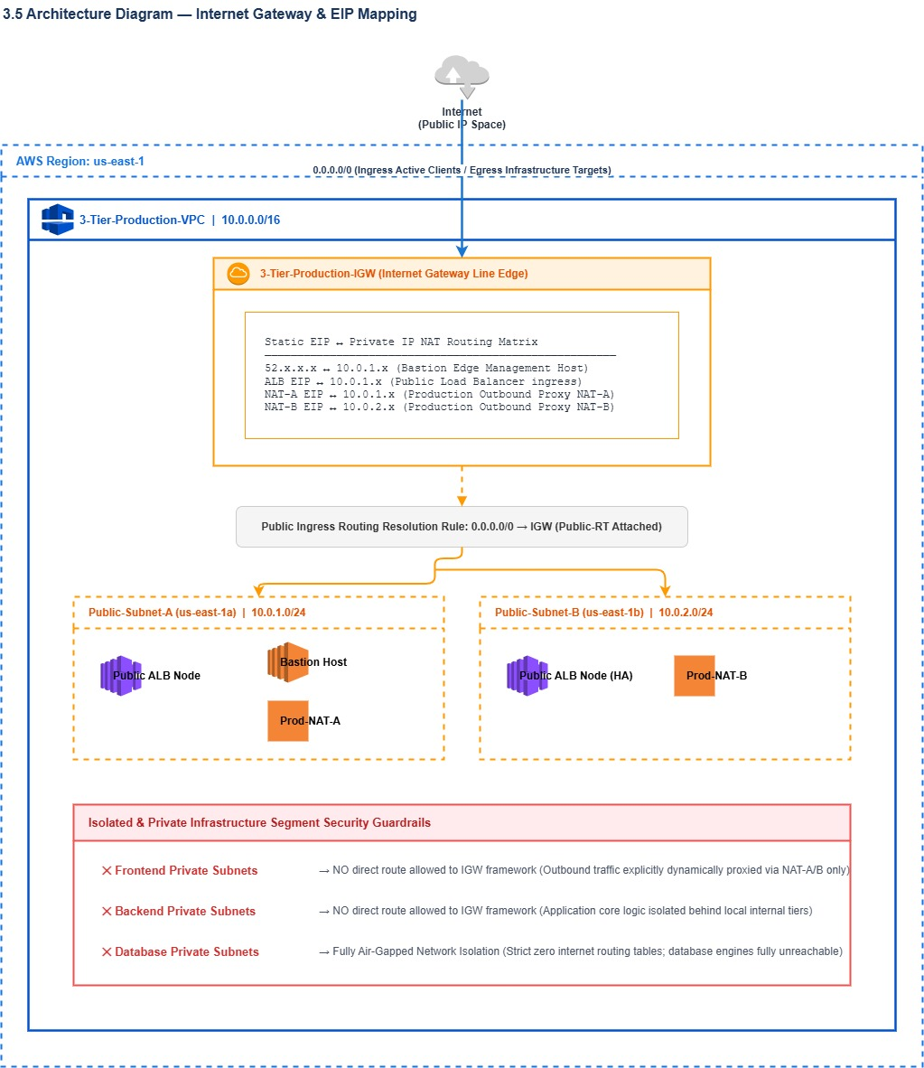

5.4 Creating Internet Gateway — AWS Console Steps
- Go to VPC Console → Internet Gateways → Create internet gateway
- Name tag: Enter "medishift-igw"
- Click "Create internet gateway"
- After creation, click "Attach to VPC" (shown in green banner)
- Select your Production-VPC from the dropdown
- Click "Attach internet gateway"

Important Notes
• One Internet Gateway can only be attached to ONE VPC
• One VPC can only have ONE Internet Gateway
• IGW is managed by AWS — no availability concerns on your part
• Creating the IGW is not enough — you must configure route tables to USE it

Chapter 6: NAT Gateway

6.1 What is a NAT Gateway?
A NAT (Network Address Translation) Gateway enables instances in a private subnet to connect to the internet or other AWS services, but prevents the internet from initiating a connection with those instances. NAT Gateway is deployed in a public subnet and uses an Elastic IP address.

The Security Need for NAT Gateway
Problem: Private subnet instances (backend, database) need outbound internet access:
• To install software packages (apt-get, npm, pip)
• To download security updates
• To connect to external APIs
• To pull Docker images

But we cannot give them public IPs — that would expose them to the internet!

Solution: NAT Gateway
→ Private instance sends traffic to NAT Gateway (in public subnet)
→ NAT Gateway has a public IP (Elastic IP)
→ NAT Gateway forwards the request to the internet using its public IP
→ Response comes back to NAT Gateway, which forwards it to the private instance
→ The internet only ever sees the NAT Gateway's IP, never the private instance

6.2 NAT Gateway Traffic Flow
NAT Gateway Complete Traffic Flow
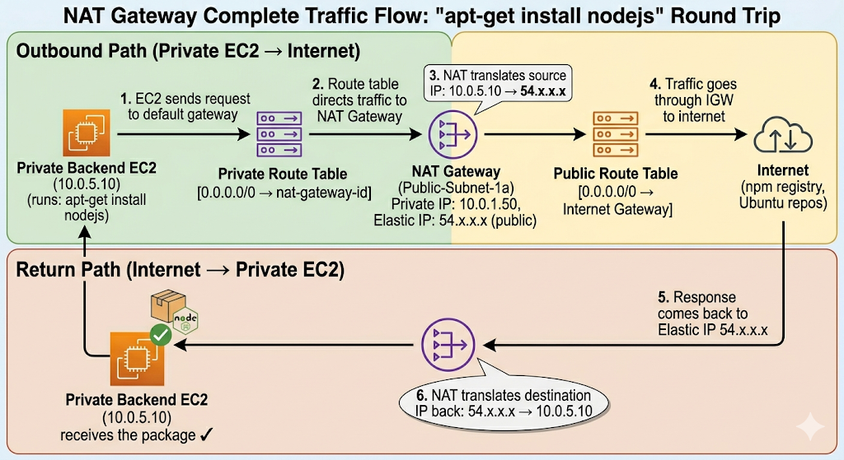

6.3 High Availability Design for NAT Gateway
NAT Gateway is an Availability Zone resource. For true high availability:
- Best Practice: Deploy one NAT Gateway per Availability Zone
- Each private route table in an AZ should route to the NAT Gateway in THAT AZ
- If NAT-GW-1a fails, only AZ-1a resources lose outbound internet — AZ-1b continues
- In our architecture: We use one NAT Gateway (cost optimization for training)
- Production best practice: NAT Gateway in each AZ used by private instances

6.4 Creating NAT Gateway — AWS Console Steps
- First create an Elastic IP (see Chapter 7)
- Go to VPC Console → NAT Gateways → Create NAT Gateway
- Name: Enter "medishift-nat-gw"
- Subnet: Select "Public-Subnet-1a" (NAT GW MUST be in a public subnet)
- Connectivity type: Select "Public"
- Elastic IP allocation ID: Select the Elastic IP you created
- Click "Create NAT Gateway"
- Wait for Status to show "Available" (takes 1-2 minutes)

Common Mistakes with NAT Gateway
✗ WRONG: Placing NAT Gateway in a private subnet (it will not work)
✗ WRONG: Not attaching an Elastic IP (NAT GW requires a static public IP)
✗ WRONG: Forgetting to update private route tables to point to NAT GW

✓ CORRECT: NAT GW in public subnet with Elastic IP
✓ CORRECT: Private route tables have 0.0.0.0/0 → nat-gateway-id
✓ CORRECT: Public subnet route table has 0.0.0.0/0 → internet-gateway-id

Chapter 7: Elastic IP Addresses

7.1 What is an Elastic IP?
An Elastic IP address is a static, public IPv4 address designed for dynamic cloud computing. Unlike regular public IP addresses that change when you stop/start an EC2 instance, an Elastic IP address is persistent — it remains yours until you explicitly release it.

7.2 Why Elastic IP is Needed for NAT Gateway
- NAT Gateway requires a static public IP address to function
- This static IP is used as the source address for all outbound traffic from private instances
- Whitelist this IP with external services (e.g., third-party APIs that allowlist by IP)
- The Elastic IP remains consistent even if the underlying NAT Gateway infrastructure changes

7.3 Allocating an Elastic IP — AWS Console Steps
- Go to VPC Console → Elastic IPs → Allocate Elastic IP address
- Network border group: Leave as default (us-east-1)
- Public IPv4 address pool: Amazon's pool of IPv4 addresses
- Click "Allocate"
- Note the allocated public IP address
- Add a Name tag: "medishift-nat-eip"

Important: Elastic IP Billing
• Elastic IPs are FREE when associated with a running EC2 instance or NAT Gateway
• Elastic IPs COST MONEY when allocated but NOT associated with any resource
• Always release Elastic IPs you are not using to avoid unexpected charges
• AWS charges approximately $0.005/hour for unassociated Elastic IPs

Chapter 8: Route Tables

8.1 What is a Route Table?
A route table contains a set of rules (routes) that determine where network traffic from your subnet or gateway is directed. Every subnet in your VPC must be associated with a route table — this is what makes a subnet "public" or "private."

How Route Tables Work
When a packet needs to travel from one place to another:
1. The router looks at the packet's destination IP address
2. The router searches the route table for a matching route
3. Most specific route wins (longest prefix match)
4. Packet is sent to the specified target

Example route table entry:
Destination Target
10.0.0.0/16 → local (VPC-internal traffic stays local)
0.0.0.0/0 → igw-xxxxxxxx (all other traffic goes to internet)

8.2 Our Route Table Configuration

Public Route Table
The public route table is associated with both public subnets. It routes internet traffic through the Internet Gateway.

Destination | Target | Purpose
10.0.0.0/16 | local | VPC-internal traffic routes locally
0.0.0.0/0 | igw-xxxxxxxx | All other traffic goes to Internet Gateway

Private Route Table (Frontend & Backend Subnets)
The private route table routes outbound internet traffic through the NAT Gateway for package downloads and updates.

Destination | Target | Purpose
10.0.0.0/16 | local | VPC-internal traffic routes locally
0.0.0.0/0 | nat-xxxxxxxx | Outbound internet traffic goes to NAT Gateway

Database Route Table
The DB subnets typically have NO route to the internet — maximum isolation. Only VPC-internal traffic is allowed.

Destination | Target | Purpose
10.0.0.0/16 | local | Only VPC-internal traffic — no internet access

8.3 Creating Route Tables — AWS Console Steps

Step 1: Create Public Route Table
- VPC Console → Route Tables → Create route table
- Name: "Public-Route-Table"
- VPC: Select your Production-VPC
- Click "Create route table"
- Select the new route table → Routes tab → Edit routes → Add route
- Destination: 0.0.0.0/0 | Target: Internet Gateway → select your IGW
- Save routes
- Subnet associations tab → Edit subnet associations
- Select Public-Subnet-1a and Public-Subnet-1b → Save

Step 2: Create Private Route Table
- Create route table: Name "Private-Route-Table", same VPC
- Add route: Destination 0.0.0.0/0, Target: NAT Gateway → select your NAT GW
- Save routes
- Associate with: Frontend-Subnet-1a, Frontend-Subnet-1b, Backend-Subnet-1a, Backend-Subnet-1b

Step 3: Create DB Route Table
- Create route table: Name "DB-Route-Table", same VPC
- Do NOT add any additional routes (only the default local route)
- Associate with: DB-Subnet-1a and DB-Subnet-1b

Chapter 9: Security Groups — Layered Security

9.1 What is a Security Group?
A Security Group acts as a virtual firewall for your EC2 instances to control inbound and outbound traffic. Security Groups are stateful — if you send a request from your instance, the response traffic for that request is allowed to flow in regardless of inbound rules.

Security Group Key Characteristics
• STATEFUL: Return traffic is automatically allowed (unlike NACLs)
• By default: ALL outbound traffic allowed, ALL inbound traffic denied
• Rules are ALLOW only — you cannot create DENY rules
• Multiple SGs can be attached to one EC2 instance
• SGs reference other SGs (not just IP addresses) for dynamic environments
• Changes to SGs take effect IMMEDIATELY — no restart required

9.2 Our Security Architecture — Layered Security Model
Security Group Layered Architecture
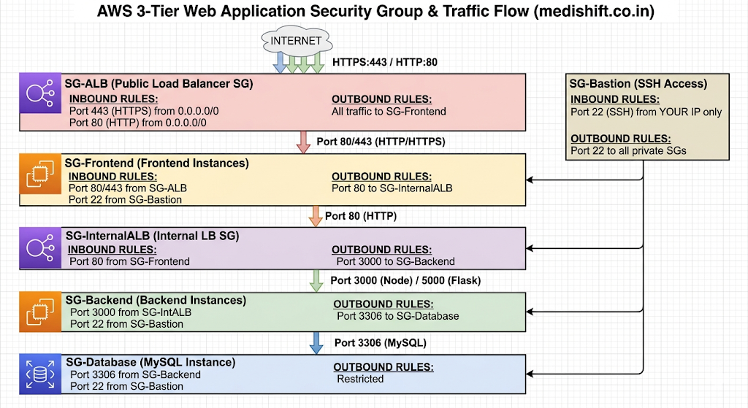

9.3 Detailed Security Group Rules

ALB Security Group (SG-ALB)
Direction | Protocol | Port | Source/Destination | Reason
Inbound | TCP | 443 | 0.0.0.0/0 (Anyone) | Accept HTTPS from internet
Inbound | TCP | 80 | 0.0.0.0/0 (Anyone) | Accept HTTP (redirect to HTTPS)
Outbound | All | All | SG-Frontend | Forward requests to frontend

Bastion Host Security Group (SG-Bastion)
Direction | Protocol | Port | Source/Destination | Reason
Inbound | TCP | 22 | Your IP /32 | SSH only from admin's IP
Outbound | TCP | 22 | SG-Frontend | SSH to frontend instances
Outbound | TCP | 22 | SG-Backend | SSH to backend instances
Outbound | TCP | 22 | SG-Database | SSH to database instance

Frontend Security Group (SG-Frontend)
Direction | Protocol | Port | Source/Destination | Reason
Inbound | TCP | 80 | SG-ALB | Accept HTTP from Load Balancer only
Inbound | TCP | 443 | SG-ALB | Accept HTTPS from Load Balancer only
Inbound | TCP | 22 | SG-Bastion | SSH from Bastion Host only
Outbound | TCP | 80 | SG-InternalALB | Send API requests to Internal ALB

Backend Security Group (SG-Backend)
Direction | Protocol | Port | Source/Destination | Reason
Inbound | TCP | 3000 | SG-InternalALB | Accept requests from Internal ALB
Inbound | TCP | 22 | SG-Bastion | SSH from Bastion Host only
Outbound | TCP | 3306 | SG-Database | Connect to MySQL database
Outbound | All | All | 0.0.0.0/0 | Outbound for updates (through NAT)

Database Security Group (SG-Database)
Direction | Protocol | Port | Source/Destination | Reason
Inbound | TCP | 3306 | SG-Backend | MySQL access from backend ONLY
Inbound | TCP | 22 | SG-Bastion | SSH from Bastion Host only
Outbound | All | All | Local VPC | Restricted outbound

9.4 Creating Security Groups — AWS Console Steps
- Go to EC2 Console → Security Groups → Create security group
- Security group name: Use descriptive names from the table above
- Description: Add a meaningful description
- VPC: Select your Production-VPC
- Add inbound rules using the tables above
- For source/destination referencing other SGs: type "sg-" and select from dropdown
- Click "Create security group"

Important: Create SGs in Order
Security Groups can reference each other, but the referenced SG must exist first.
Create in this order:
1. SG-Bastion (no SG dependencies)
2. SG-ALB (no SG dependencies)
3. SG-Frontend (depends on SG-ALB, SG-Bastion)
4. SG-InternalALB (depends on SG-Frontend)
5. SG-Backend (depends on SG-InternalALB, SG-Bastion)
6. SG-Database (depends on SG-Backend, SG-Bastion)

Chapter 10: EC2 — Elastic Compute Cloud

10.1 What is EC2?
Amazon Elastic Compute Cloud (Amazon EC2) provides scalable computing capacity in the AWS Cloud. Using EC2 eliminates your need to invest in hardware upfront, so you can develop and deploy applications faster. You can use EC2 to launch as many or as few virtual servers as you need, configure security and networking, and manage storage.

10.2 EC2 Instance Types
EC2 instances come in different "types" optimized for different use cases. For our 3-tier architecture, we use t2/t3 instances (general purpose, cost-effective for learning):
Instance Family | Purpose | Our Use
t2.micro / t3.micro | General purpose, free tier eligible | Bastion host, single instances
t2.small / t3.small | General purpose, more RAM | Frontend and backend instances
t2.medium / t3.medium | General purpose, 2 vCPU, 4GB RAM | Database server
t3.large | General purpose, production workloads | Production frontend/backend

10.3 Key Pairs — SSH Authentication
Key pairs are used to securely connect to your EC2 instances via SSH. AWS uses asymmetric key cryptography: AWS stores the public key on the instance, and you keep the private key (.pem file).

- EC2 Console → Key Pairs → Create key pair
- Name: "medishift-key-pair"
- Key pair type: RSA
- Private key file format: .pem (for Linux/Mac) or .ppk (for PuTTY on Windows)
- Click "Create key pair" — the .pem file downloads automatically
- Store this file securely — if lost, you cannot SSH into your instances

# Set correct permissions on the .pem file (required for SSH)
chmod 400 medishift-key-pair.pem

# SSH to Bastion Host (has public IP)
ssh -i medishift-key-pair.pem ubuntu@<bastion-public-ip>

# SSH to private instance through Bastion (SSH tunneling)
ssh -i medishift-key-pair.pem -J ubuntu@<bastion-ip> ubuntu@<private-instance-ip>

Chapter 11: Bastion Host — Secure Administrative Access

11.1 What is a Bastion Host?
A Bastion Host (also called a Jump Server or Jump Box) is a special-purpose EC2 instance in the public subnet that provides secure access to instances in private subnets. It acts as the single, hardened entry point for administrative SSH access to your entire private infrastructure.

Why Bastion Host is Essential
Problem Without Bastion Host:
• To SSH into private instances, you would need to give them public IPs
• Public IPs on database servers are a critical security vulnerability
• The attack surface would be massive — every server exposed to internet

Solution — Bastion Host Architecture:
• ONE server (Bastion) has a public IP — with strict SSH rules
• ALL other servers stay completely private
• Admins SSH → Bastion Host → then SSH to any private instance
• All admin access is logged through one controlled entry point
• If the Bastion Host is compromised, rotate keys — no other server affected

11.2 Bastion Host Architecture
Bastion Host Access Flow
[Admin Workstation]
Your IP: 203.x.x.x
│
│ SSH Port 22 (allowed in SG-Bastion: source 203.x.x.x/32)
▼
[Bastion Host] ← Public Subnet (10.0.1.x)
Public IP: 54.y.y.y
Private IP: 10.0.1.10
│
├── SSH Port 22 to Frontend: 10.0.3.x (allowed in SG-Frontend)
│
├── SSH Port 22 to Backend: 10.0.5.x (allowed in SG-Backend)
│
└── SSH Port 22 to Database: 10.0.7.x (allowed in SG-Database)

INTERNET CANNOT:
✗ SSH directly to Frontend (no public IP, SG blocks it)
✗ SSH directly to Backend (no public IP, SG blocks it)
✗ SSH directly to Database (no public IP, SG blocks it)
✗ SSH to Bastion from any IP other than your allowed IP

11.3 Launching the Bastion Host — AWS Console Steps
- EC2 Console → Instances → Launch Instance
- Name: "Bastion-Host"
- Application and OS Images: Ubuntu Server 22.04 LTS (free tier eligible)
- Instance type: t2.micro (or t3.micro)
- Key pair: Select medishift-key-pair
- Network settings → Edit:
  - VPC: Production-VPC
  - Subnet: Public-Subnet-1a
  - Auto-assign public IP: Enable
  - Security Group: Select SG-Bastion
- Storage: 8 GB gp3 (default is fine)
- Click "Launch Instance"

Chapter 12: Application Deployment Architecture

12.1 Our 3-Tier Application Stack
Our training architecture deploys a complete 3-tier web application with the following components:
Tier | Technology | Purpose
Frontend (Tier 1) | Apache2 / Nginx serving static HTML | User interface layer
Backend (Tier 2) | Node.js (Express) or Python Flask | API / business logic layer
Database (Tier 3) | MySQL on EC2 | Data persistence layer

12.2 GitHub Repository Reference
The application code is available at: https://github.com/rajcocvs/Three-Tier

Repository Structure Overview
The Three-Tier repository contains:

/frontend/
index.html ← Static HTML page served by Apache/Nginx
styles.css ← CSS styles
app.js ← Frontend JavaScript

/backend/
server.js ← Node.js Express server (Port 3000)
app.py ← Python Flask server (Port 5000)
package.json ← Node.js dependencies
requirements.txt ← Python dependencies

/database/
schema.sql ← MySQL database schema and initial data
setup.sh ← Database initialization script

12.3 Frontend Deployment

Option A: Apache2 Static Site
#!/bin/bash
# Frontend User Data script - Apache2
apt-get update -y
apt-get install -y apache2 git
systemctl start apache2
systemctl enable apache2

# Clone repository
cd /var/www/html
git clone https://github.com/rajcocvs/Three-Tier.git .

# Nginx as reverse proxy for API calls
apt-get install -y nginx
# Configure Nginx to proxy /api → Internal ALB

Option B: Nginx Reverse Proxy
# /etc/nginx/sites-available/default
server {
listen 80;
server_name _;

# Serve static frontend
location / {
root /var/www/html;
index index.html;
}

# Proxy API calls to Internal ALB
location /api/ {
proxy_pass http://<Internal-ALB-DNS>/;
proxy_set_header Host $host;
proxy_set_header X-Real-IP $remote_addr;
}
}

12.4 Backend Deployment

Node.js Express Backend
#!/bin/bash
# Backend User Data script - Node.js
apt-get update -y
apt-get install -y nodejs npm git

cd /home/ubuntu
git clone https://github.com/rajcocvs/Three-Tier.git
cd Three-Tier/backend
npm install

# Start application (use PM2 for production)
npm install -g pm2
pm2 start server.js
pm2 startup
pm2 save

12.5 Database Deployment
#!/bin/bash
# Database User Data script - MySQL
apt-get update -y
apt-get install -y mysql-server

systemctl start mysql
systemctl enable mysql

# Secure MySQL and create application database
mysql -e "ALTER USER 'root'@'localhost' IDENTIFIED WITH mysql_native_password BY 'SecurePass123!';"
mysql -e "CREATE DATABASE medishift_db;"
mysql -e "CREATE USER 'appuser'@'%' IDENTIFIED BY 'AppPass123!';"
mysql -e "GRANT ALL ON medishift_db.* TO 'appuser'@'%';"
mysql -e "FLUSH PRIVILEGES;"

# Allow remote connections (MySQL listens on all interfaces)
sed -i "s/bind-address.*/bind-address = 0.0.0.0/" /etc/mysql/mysql.conf.d/mysqld.cnf
systemctl restart mysql

Chapter 13: User Data Scripts

13.1 What is EC2 User Data?
User Data is a script that runs automatically when an EC2 instance launches for the first time. It allows you to automate instance configuration, software installation, and application deployment without manual intervention.

User Data Key Facts
• Runs ONLY once — on first boot of the instance
• Runs as root user (no need for sudo)
• Output logs go to /var/log/cloud-init-output.log
• Maximum size: 16 KB
• Must start with #!/bin/bash (for shell scripts)
• Used with Launch Templates for Auto Scaling Groups
• Enables fully automated, reproducible deployments

13.2 Why User Data is Critical for Auto Scaling
When an Auto Scaling Group launches a new EC2 instance (due to scaling events or instance failures), that instance must automatically configure itself without human intervention. User Data makes this possible.

- New instance launches → User Data script runs → Application is ready in minutes
- No manual SSH needed to configure new instances
- Every instance created by ASG is identical — same User Data, same configuration
- Self-healing: When a failed instance is replaced, the replacement auto-configures

13.3 Adding User Data in AWS Console
- When launching an EC2 instance: scroll to "Advanced details" at the bottom
- Find "User data" field
- Select "As text" radio button
- Paste your bash script (including #!/bin/bash at the top)
- Complete the rest of the instance launch configuration

Debugging User Data
If your instance launches but the application is not running:

1. SSH into the instance
2. Check the User Data log:
cat /var/log/cloud-init-output.log

3. Look for errors in the output
4. Common issues:
- Package not found: check apt repository is updated
- Permission denied: script not running as root?
- Network errors: NAT Gateway not configured correctly

Chapter 14: Target Groups

14.1 What is a Target Group?
A Target Group is a logical grouping of targets (EC2 instances, IP addresses, or Lambda functions) that the Application Load Balancer routes requests to. The load balancer distributes incoming traffic across all registered, healthy targets in a target group.

Target Group Analogy
Think of a Target Group like a team roster:

Target Group = Team
EC2 instances = Team members
ALB = Manager who assigns work

The manager checks who is available (health check)
Then sends work (traffic) only to available, healthy team members
If a team member is sick (unhealthy), manager stops sending them work

14.2 Health Checks
Health checks are continuous tests the ALB performs on each target to determine if it is healthy and able to receive traffic. Unhealthy targets are automatically removed from rotation.
Health Check Setting | Our Configuration | Explanation
Protocol | HTTP | ALB sends HTTP requests to test health
Path | /health or / | The URL path ALB checks
Port | Traffic port | Same port as application
Healthy threshold | 2 | Consecutive successes before marking healthy
Unhealthy threshold | 3 | Consecutive failures before marking unhealthy
Timeout | 5 seconds | Time to wait for health check response
Interval | 30 seconds | Time between health checks
Success codes | 200 | HTTP response codes that indicate health

14.3 Our Target Groups
- Frontend-TG: Contains frontend EC2 instances, Port 80, Protocol HTTP
- Backend-TG: Contains backend EC2 instances, Port 3000, Protocol HTTP

14.4 Creating Target Groups — AWS Console Steps
- EC2 Console → Load Balancing → Target Groups → Create target group
- Target type: "Instances"
- Target group name: "Frontend-TG"
- Protocol: HTTP | Port: 80
- VPC: Production-VPC
- Protocol version: HTTP1
- Health check protocol: HTTP | Path: /
- Advanced health check settings: Configure thresholds as above
- Click "Next" → Register targets (skip for now — ASG will register)
- Click "Create target group"
Repeat for Backend-TG with Port 3000.

Chapter 15: Application Load Balancer (ALB)

15.1 What is an Application Load Balancer?
The Application Load Balancer (ALB) is a Layer 7 (application layer) load balancer that makes routing decisions based on the content of the request — including HTTP headers, methods, query strings, paths, source IP addresses, and host names. It distributes incoming traffic across multiple EC2 instances to ensure no single server is overwhelmed.

15.2 Why ALB is Needed
- Single Point of Entry: One DNS name for your application regardless of how many servers are running
- High Availability: Traffic is distributed across multiple AZs and instances
- Health-Based Routing: Automatically stops sending traffic to unhealthy instances
- SSL Termination: Handles HTTPS encryption/decryption — reduces load on instances
- Advanced Routing: Route based on URL path, host header, query string, etc.
- Auto Scaling Integration: Automatically registers/deregisters instances as they scale

15.3 ALB Request Flow
Complete ALB Request Flow
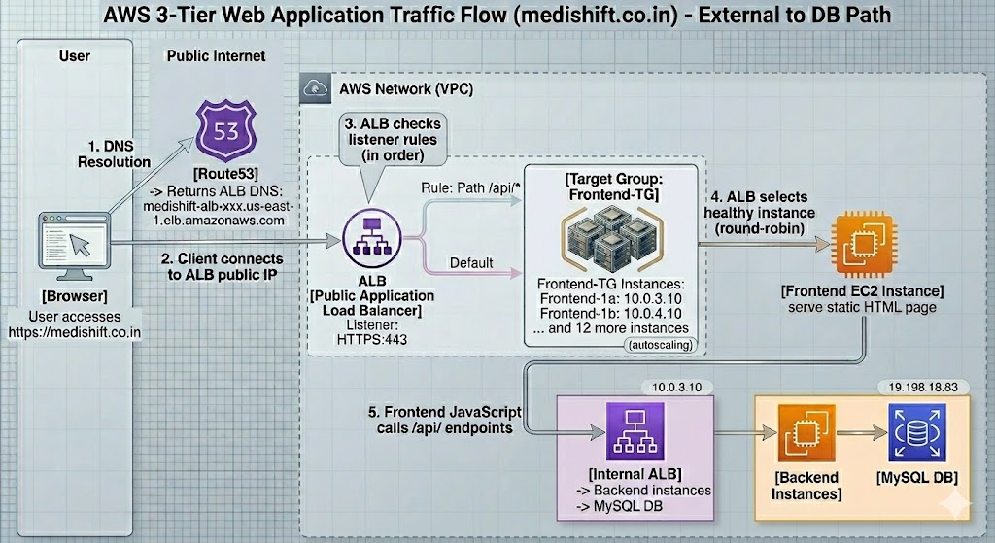

15.4 Creating the Public ALB — AWS Console Steps
- EC2 Console → Load Balancing → Load Balancers → Create load balancer
- Select "Application Load Balancer"
- Basic configuration:
  - Name: "medishift-public-alb"
  - Scheme: Internet-facing
  - IP address type: IPv4
- Network mapping:
  - VPC: Production-VPC
  - Mappings: Select us-east-1a → Public-Subnet-1a
  - Select us-east-1b → Public-Subnet-1b
- Security groups: Select SG-ALB
- Listeners and routing:
  - Protocol: HTTPS | Port: 443 | Default action: Forward to Frontend-TG
  - Add listener: HTTP:80 → Redirect to HTTPS:443
- Secure listener settings: Certificate from ACM (configure after ACM setup)
- Click "Create load balancer"

15.5 Internal Application Load Balancer
The Internal ALB is identical to the Public ALB except:
- Scheme: Internal (no public IP, not reachable from internet)
- Placed in private subnets (Frontend-Subnet-1a and Frontend-Subnet-1b)
- Security Group: SG-InternalALB (only accepts traffic from SG-Frontend)
- Routes traffic from Frontend to Backend instances

Create using same steps but select: Scheme = "Internal", Subnets = Frontend private subnets, SG = SG-InternalALB, Default action → Backend-TG.

Chapter 16: ALB Routing Types

Training Note
During training, each routing type was implemented SEPARATELY using:
• Separate ALB instances dedicated to each routing type
• Ubuntu EC2 instances with User Data scripts demonstrating each routing type
• This isolated approach allowed focused learning of each concept

In production, all routing types can be combined in listener rules of a single ALB.

16.1 Path-Based Routing
Path-based routing directs requests to different target groups based on the URL path. This is the most commonly used routing type for microservices architectures.

URL Path | Routes To | Use Case
/ | Frontend Target Group | Main website / homepage
/api/* | Backend Target Group | All API endpoints
/admin/* | Admin Target Group | Admin dashboard
/static/* | Static content servers | CSS, JS, images

AWS Console — Configure Path-Based Routing
- Go to your ALB → Listeners tab → Click on your HTTPS listener
- Click "Add rule"
- Rule name: "API-Routing"
- Add condition: Path → is → /api/*
- Add action: Forward to → Backend-TG
- Priority: 1 (lower number = higher priority)
- Click "Create rule"

# Traffic flow example:
# https://medishift.co.in/ → Frontend-TG (default rule)
# https://medishift.co.in/api/users → Backend-TG (path rule: /api/*)
# https://medishift.co.in/api/data → Backend-TG (path rule: /api/*)

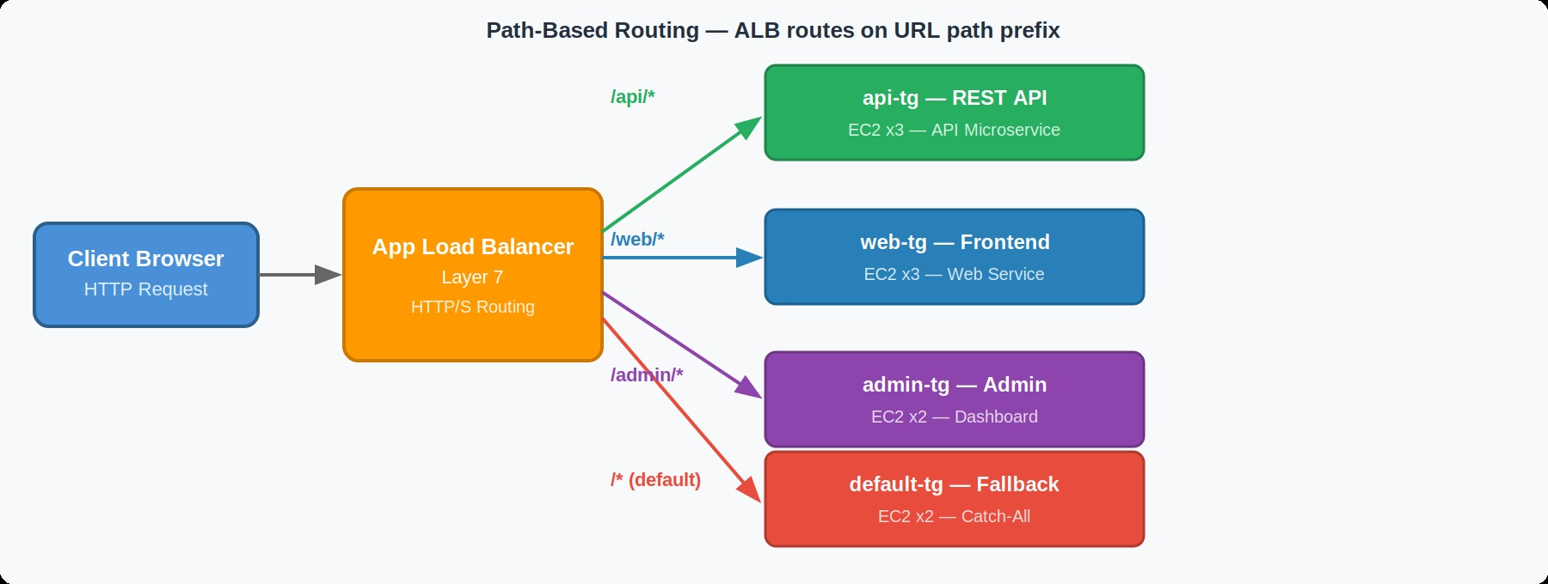

16.2 Host-Based Routing
Host-based routing directs requests to different target groups based on the HTTP Host header (the domain or subdomain in the URL).

Host Header | Routes To | Use Case
medishift.co.in | Frontend Target Group | Main website
admin.medishift.co.in | Admin Target Group | Admin portal
api.medishift.co.in | Backend Target Group | API subdomain
app.medishift.co.in | App Target Group | Mobile app API

AWS Console — Configure Host-Based Routing
- ALB → Listeners → Add rule
- Add condition: Host header → is → admin.medishift.co.in
- Add action: Forward to → Admin-TG
- Create a DNS record: admin.medishift.co.in → this ALB

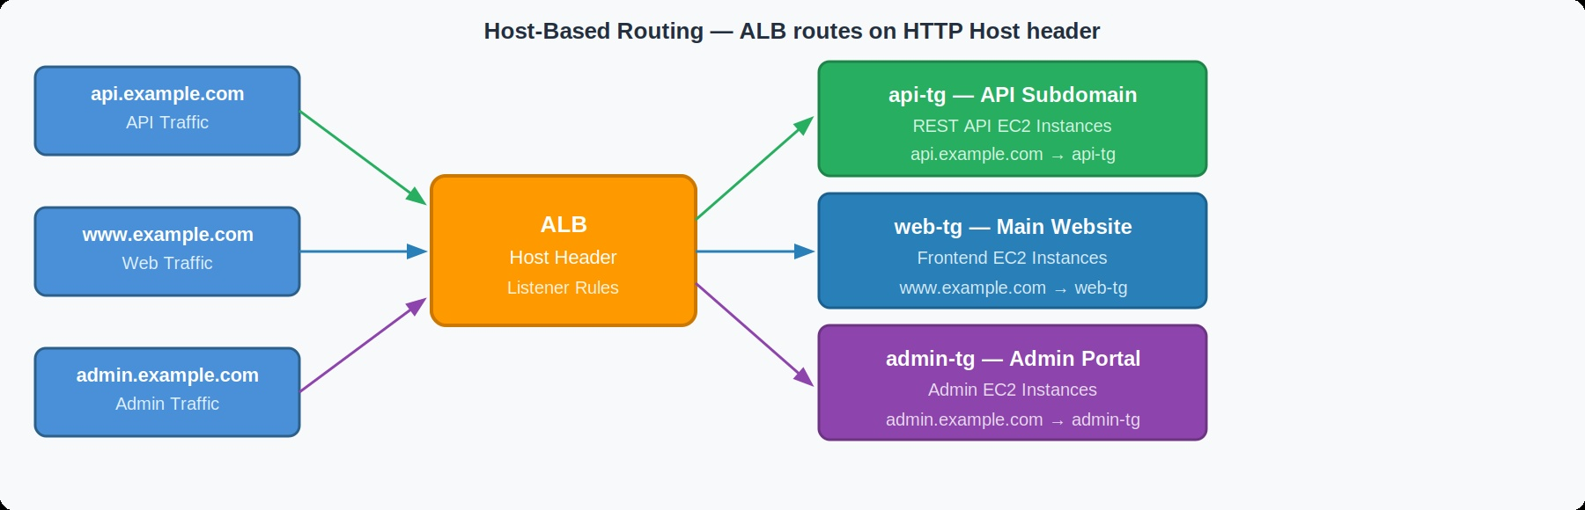

16.3 Query String Routing
Query string routing directs requests based on URL query parameters. Useful for A/B testing, feature flags, or environment-based routing.

Query String | Routes To | Use Case
?env=prod | Production Target Group | Production environment
?env=staging | Staging Target Group | Staging/test environment
?version=v2 | V2 Target Group | Blue-green deployment
?region=us | US Target Group | Regional routing

AWS Console — Configure Query String Routing
- ALB → Listeners → Add rule
- Add condition: Query string → key: env, value: staging
- Add action: Forward to → Staging-TG

16.4 HTTP Header-Based Routing
Header-based routing uses custom HTTP headers to route requests. This is commonly used for internal API versioning, device-based routing, or canary deployments.

HTTP Header | Value | Routes To
X-API-Version | v2 | V2 Backend Target Group
X-Device-Type | mobile | Mobile-optimized Target Group
X-Customer-Tier | premium | Premium service Target Group
User-Agent | contains iOS | iOS-specific Target Group

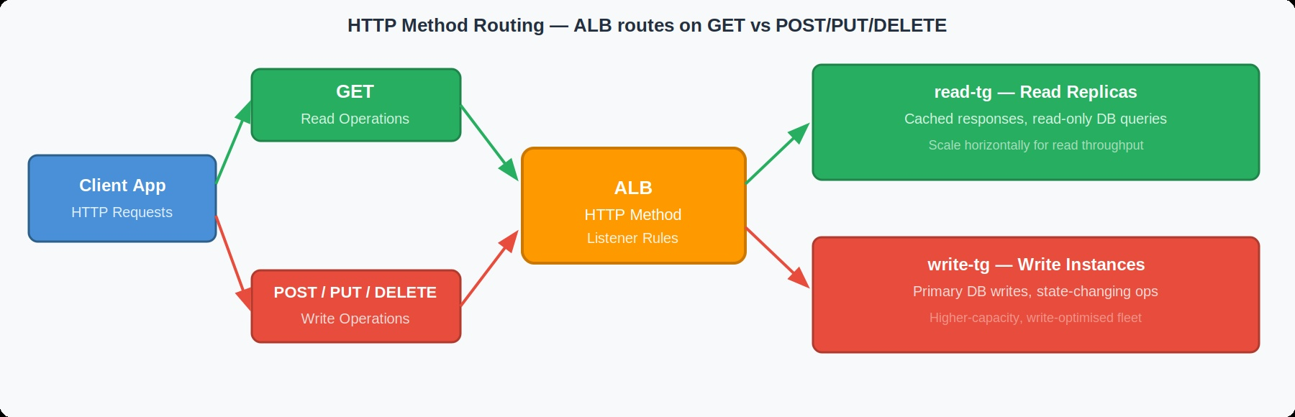

16.5 Source IP-Based Routing
Source IP routing directs traffic based on the client's IP address. This is useful for routing internal corporate traffic differently, geographic routing, or allowing only specific IPs to access certain services.
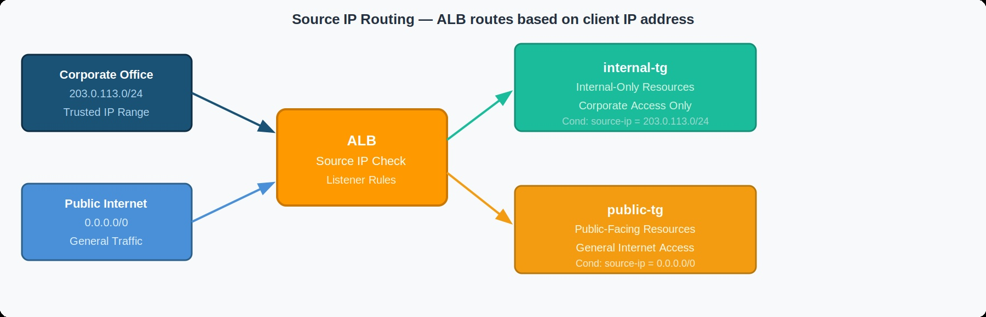

Source IP/CIDR | Routes To | Use Case
10.0.0.0/8 (private) | Internal Target Group | Internal corporate traffic
203.x.x.x/32 (office IP) | Admin Target Group | Office IP access to admin
0.0.0.0/0 (everyone else) | Public Target Group | All other internet traffic

Chapter 17: Auto Scaling

17.1 Why Auto Scaling is Needed
Auto Scaling is the ability of your infrastructure to automatically adjust the number of EC2 instances based on actual demand. Without auto scaling, you must manually add or remove servers — which is slow, expensive, and error-prone.

Auto Scaling Business Value
Without Auto Scaling:
• Weekend traffic spike: site crashes, revenue lost
• Overnight low traffic: you pay for idle servers
• Manual scaling: engineer woken at 2 AM to add servers

With Auto Scaling:
• Weekend traffic spike: new servers launch automatically in minutes
• Overnight low traffic: servers automatically terminate to save cost
• No manual intervention: system manages itself
• Self-healing: failed instances automatically replaced

17.2 Launch Templates
A Launch Template is a versioned template that specifies the EC2 configuration for instances launched by an Auto Scaling Group. It eliminates the need to configure new instances manually each time.

Creating a Launch Template — AWS Console Steps
- EC2 Console → Launch Templates → Create launch template
- Launch template name: "Frontend-LT"
- Application and OS Images: Ubuntu Server 22.04 LTS
- Instance type: t3.small
- Key pair: medishift-key-pair
- Network settings: Select SG-Frontend (do NOT specify subnet here — ASG handlesthis)
- Advanced details → User data: Paste your frontend startup script
- Click "Create launch template"

17.3 Auto Scaling Groups
An Auto Scaling Group (ASG) is a logical collection of EC2 instances managed together. The ASG uses the Launch Template to launch instances and maintains the desired number of running instances.

Auto Scaling Group Behavior
ASG Configuration:
Minimum: 2 instances ← Never scale below this
Desired: 2 instances ← Start with this many
Maximum: 6 instances ← Never exceed this

Normal Operation:
[Instance 1 AZ-1a] [Instance 2 AZ-1b] ← 2 desired

High Traffic (CPU > 70%):
[Inst 1] [Inst 2] [Inst 3] [Inst 4] ← Scale out to 4

Instance 1 fails health check:
[FAILED] [Inst 2] [Inst 3] ← ASG replaces failed
[NEW] [Inst 2] [Inst 3] ← Self-healing ✓

Traffic drops (CPU < 30%):
[Inst 1] [Inst 2] ← Scale in to minimum

Creating Auto Scaling Group — AWS Console Steps
- EC2 Console → Auto Scaling Groups → Create Auto Scaling group
- Name: "Frontend-ASG"
- Launch template: Select "Frontend-LT" (latest version)
- Click "Next"
- Network:
  - VPC: Production-VPC
  - Availability Zones and subnets: Select Frontend-Subnet-1a AND Frontend-Subnet-1b
- Load balancing: Attach to existing load balancer
  - Target groups: Select Frontend-TG
- Health checks: Enable ELB health checks (in addition to EC2 health checks)
- Click "Next"
- Group size:
  - Desired capacity: 2
  - Minimum capacity: 2
  - Maximum capacity: 6
- Scaling policies: Select "Target tracking scaling policy"
  - Metric type: Average CPU Utilization
  - Target value: 70 (scale out when average CPU > 70%)
- Click "Next" → Review → Create Auto Scaling group

Repeat the same process for Backend-ASG using Backend-LT, Backend-Subnet-1a/1b, and Backend-TG.

Chapter 18: ACM — AWS Certificate Manager

18.1 SSL/TLS and HTTPS Fundamentals
SSL (Secure Sockets Layer) and its modern successor TLS (Transport Layer Security) are cryptographic protocols that provide secure communication over the internet. HTTPS is HTTP with SSL/TLS encryption.

Why HTTPS is Non-Negotiable in Production
Without HTTPS:
✗ All data transmitted in plain text — passwords, credit cards visible
✗ Man-in-the-Middle attacks can intercept and modify traffic
✗ Modern browsers show "Not Secure" warning → users leave
✗ Google ranks HTTP sites lower in search results
✗ Payment processors (Stripe, PayPal) require HTTPS

With HTTPS:
✓ All data encrypted in transit — unreadable if intercepted
✓ Browser shows padlock — users trust your site
✓ Better Google search ranking
✓ Required for payment processing, sensitive data
✓ Required for HTTP/2 (faster web protocol)

18.2 What is AWS Certificate Manager?
AWS Certificate Manager (ACM) is a service that lets you easily provision, manage, and deploy SSL/TLS certificates for use with AWS services. ACM handles the complexity of creating and managing certificates — and it's FREE for certificates used with AWS services like ALB.

18.3 Requesting an ACM Certificate — AWS Console Steps
- Go to AWS Console → Certificate Manager (ACM)
- IMPORTANT: Must be in us-east-1 region for use with most global services
- Click "Request" → "Request a public certificate"
- Fully qualified domain names:
  - Enter: medishift.co.in
  - Click "Add another name to this certificate"
  - Enter: *.medishift.co.in (wildcard — covers all subdomains)
- Validation method: Select "DNS validation" (recommended)
- Key algorithm: RSA 2048
- Click "Request"
- After request, click on the certificate to view details
- Under "Domains" — click "Create records in Route53" (if your domain is in Route53)
- AWS automatically creates the CNAME validation records in Route53
- Wait 5-30 minutes for validation — Status changes from "Pending validation" to "Issued"

DNS Validation Explained
ACM needs to prove you OWN the domain medishift.co.in.
It does this through DNS validation:

1. ACM gives you a specific CNAME record to add to your DNS
Example: _abc123.medishift.co.in CNAME _def456.acm-validations.aws

2. You add this record to Route53 (or your DNS provider)

3. ACM checks if this record exists in your DNS

4. If it exists → you must own the domain → certificate issued

Advantage of DNS validation: Certificate auto-renews before expiration!

Chapter 19: Route53 — DNS Management

19.1 What is DNS?
DNS (Domain Name System) is often called "the phone book of the internet." It translates human-readable domain names (like medishift.co.in) into machine-readable IP addresses (like 54.210.x.x) that computers use to communicate.

DNS Without Technical Jargon
Problem: Computers communicate using IP addresses (numbers like 54.210.123.456)
Problem: Humans remember names, not numbers

DNS Solution:
You type: medishift.co.in
DNS says: "That's actually at IP 54.210.123.456"
Browser connects to: 54.210.123.456

It's exactly like a phone contact list:
You know: "Call Mom"
Phone knows: Mom = +1-555-123-4567
Phone dials: +1-555-123-4567

19.2 What is Route53?
Amazon Route53 is AWS's highly available and scalable DNS web service. The name "Route53" comes from two things: "Route" (as in routing network traffic) and "53" (port 53 is the standard port for DNS protocol).

- 99.99% availability SLA — AWS guarantees DNS is always up
- Uses AWS edge locations (400+) for fastest DNS resolution globally
- Integrates natively with ALB, CloudFront, and other AWS services
- Supports advanced routing policies for HA and failover

19.3 Hosted Zones
A Hosted Zone is a container for DNS records for a specific domain. When you register medishift.co.in, you create a hosted zone that holds all the DNS records for that domain.

Creating a Hosted Zone — AWS Console Steps
- Go to Route53 Console → Hosted zones → Create hosted zone
- Domain name: medishift.co.in
- Type: Public hosted zone
- Click "Create hosted zone"
- AWS automatically creates 2 records:
  - NS record: Lists 4 Route53 name servers for your domain
  - SOA record: Start of Authority — administrative info about the zone
- Copy the 4 NS server names (e.g., ns-1234.awsdns-12.com)
- Update your domain registrar to use these Route53 name servers

19.4 DNS Resolution Flow Diagram
Complete DNS Resolution Flow for medishift.co.in
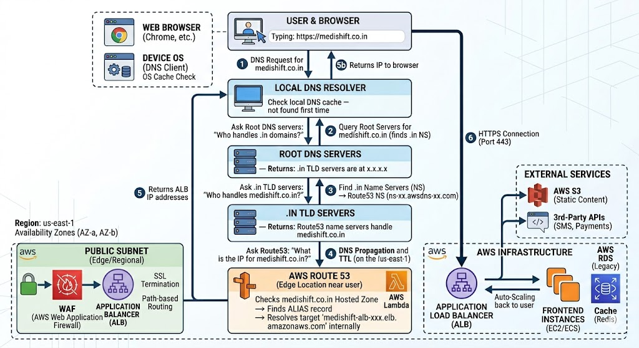

19.5 DNS Record Types

A Record (Address Record)
An A record maps a domain name directly to an IPv4 address.
Name | Type | Value | Use Case
bastion.medishift.co.in | A | 54.210.x.x | Bastion host direct IP mapping
mail.medishift.co.in | A | 52.x.x.x | Mail server IP mapping

CNAME Record (Canonical Name Record)
A CNAME record maps a domain name to another domain name (not directly to an IP). Used when you want one name to be an alias for another.
Name | Type | Value | Use Case
www.medishift.co.in | CNAME | medishift.co.in | www redirects to apex domain
shop.medishift.co.in | CNAME | store.shopify.com | Points to external service

Alias Record (AWS-Specific)
An Alias record is an AWS Route53 extension that maps a domain to an AWS resource (ALB, CloudFront, S3 website, etc.). Unlike CNAME, Alias records can be used at the zone apex (root domain like medishift.co.in).
Name | Type | Value | Use Case
medishift.co.in | A (Alias) | medishift-alb-xxx.elb.amazonaws.com | Root domain → ALB
*.medishift.co.in | A (Alias) | medishift-alb-xxx.elb.amazonaws.com | Wildcard → ALB

Alias vs CNAME — Key Differences
Alias Record:
✓ Works at zone apex (medishift.co.in) — CNAME cannot!
✓ FREE — no charge for Route53 Alias queries
✓ Auto-updates when AWS resource IP changes
✓ Integrates with ALB health checks
✗ Only works with AWS resources

CNAME Record:
✓ Works with any external service
✗ Cannot be used at zone apex
✗ Costs money per query
✗ Does not auto-update

19.6 Creating DNS Records — AWS Console Steps

Creating an Alias Record for Root Domain
- Route53 Console → Hosted Zones → medishift.co.in → Create record
- Record name: (leave blank for root domain)
- Record type: A
- Toggle ON: "Alias"
- Route traffic to: "Alias to Application and Classic Load Balancer"
- Region: US East (N. Virginia)
- Load balancer: Select your public ALB from dropdown
- Routing policy: Simple routing
- Click "Create records"

Chapter 20: Route53 Routing Policies

Route53 routing policies determine HOW Route53 responds to DNS queries. Different policies enable different traffic management strategies.

20.1 Simple Routing
Simple routing returns a single resource (one IP or one AWS resource) for a given domain name. It is the default routing policy — no intelligence, no health checks, no failover.

Simple Routing — When to Use
Use Case: You have a single resource serving your domain.

medishift.co.in → Single ALB → Frontend instances

Behavior:
• Always returns the same IP/resource
• No health checks
• No failover capability
• Simplest to configure

Real-World Example:
Small startup with single region deployment
Development or staging environments

20.2 Geolocation Routing
Geolocation routing routes traffic to different resources based on the geographic location of the DNS query (where the user is located). This allows you to serve localized content and comply with data residency laws.
User Location | Route To | Business Reason
United States | us-east-1 ALB | Serve US users from US region
Europe | eu-west-1 ALB | GDPR compliance — EU data in EU
Asia Pacific | ap-southeast-1 ALB | Lower latency for Asian users
Default | us-east-1 ALB | Fallback for unmatched locations

Geolocation Routing — Setup in Console
1. Create record for each geographic region:
- Create record: medishift.co.in → US ALB
Routing policy: Geolocation
Location: United States

- Create record: medishift.co.in → EU ALB
Routing policy: Geolocation
Location: Europe

- Create record: medishift.co.in → US ALB
Routing policy: Geolocation
Location: Default (mandatory fallback)

2. Assign different health checks to each

20.3 Failover Routing
Failover routing automatically routes traffic to a secondary resource when the primary resource is unhealthy. This is essential for disaster recovery architectures.

Failover Routing — Disaster Recovery Flow
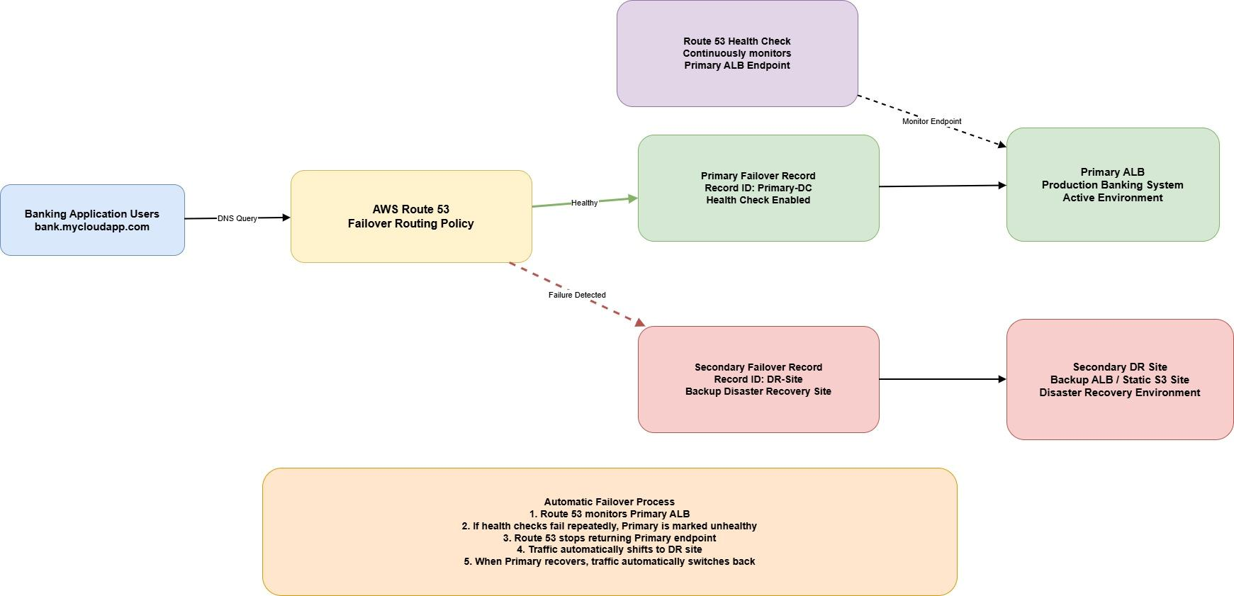

20.4 Multi-Value Routing
Multi-value routing returns up to 8 healthy records randomly for a given query. It is similar to simple routing with multiple values, but each value has a health check — unhealthy values are NOT returned.

Feature | Multi-Value Routing | Simple Routing (multiple)
Health checks | Per record — unhealthy filtered out | Not supported
Number of values returned | Up to 8 healthy values | All values (including unhealthy)
Load distribution | Client-side random selection | Client-side selection
Use case | Simple HA without ALB | Single resource only

Chapter 21: Complete HTTPS Architecture

This chapter explains how ACM, Route53, and ALB work together to deliver secure HTTPS traffic to your application.

Complete HTTPS Request Flow: medishift.co.in
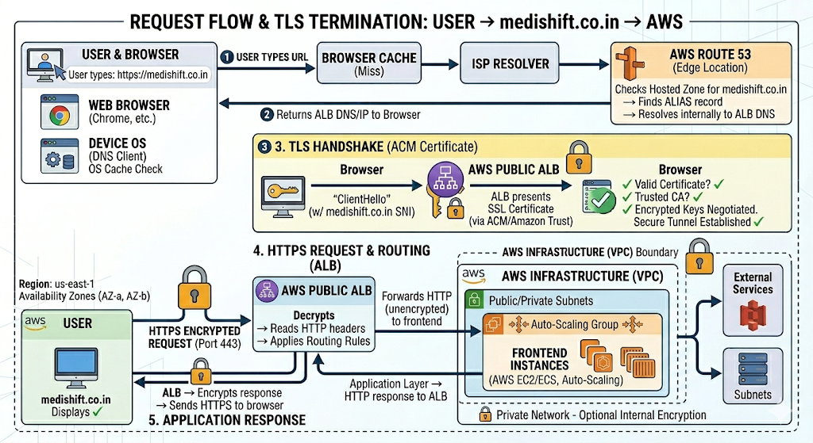

21.1 Attaching ACM Certificate to ALB
- EC2 Console → Load Balancers → Select your public ALB
- Listeners tab → Select HTTPS:443 listener → Edit
- Default SSL/TLS certificate → Add from ACM
- Select your medishift.co.in certificate (must show "Issued" status)
- Click "Update"

21.2 HTTP to HTTPS Redirect
Always redirect HTTP to HTTPS to ensure all traffic is encrypted:
- ALB → Listeners tab → HTTP:80 listener → Edit
- Default action: Change to "Redirect"
- Protocol: HTTPS | Port: 443 | Status code: 301 (permanent redirect)
- Click "Update"

Chapter 22: High Availability Architecture

22.1 What is High Availability?
High Availability (HA) means your application continues to operate without interruption even when individual components fail. It is achieved through redundancy — having multiple copies of every critical component so that when one fails, another takes over automatically.

HA Target: 99.99% Uptime
Availability | Downtime per Year
99% | 3 days, 15 hours, 36 minutes
99.9% (3 9s) | 8 hours, 45 minutes
99.99% (4 9s) | 52 minutes
99.999%(5 9s) | 5 minutes

Our architecture targets 99.99% through:
• Multi-AZ deployment (AZ failure resilience)
• Auto Scaling Groups (instance failure resilience)
• ALB health checks (automatic failover)
• Multi-AZ NAT Gateway (connectivity resilience)

22.2 How Multi-AZ Provides HA
High Availability — AZ Failure Scenario
NORMAL OPERATION:
ALB distributes traffic across both AZs equally

[Public ALB]
├── Frontend-1a (10.0.3.10) AZ-1a ← receives 50% traffic
└── Frontend-1b (10.0.4.10) AZ-1b ← receives 50% traffic

AZ-1a FAILURE SCENARIO:
Entire us-east-1a data center experiences outage

[Public ALB]
├── Frontend-1a (10.0.3.10) AZ-1a ← FAILED ✗ (removed by ALB)
└── Frontend-1b (10.0.4.10) AZ-1b ← receives 100% traffic

ASG detects instance count below minimum (2):
└── Launches new Frontend-1a in AZ-1a when AZ recovers

USER IMPACT: Zero. Application continues serving users.
RECOVERY TIME: Automatic. No human intervention required.

22.3 HA at Each Tier
Tier | HA Mechanism | Failure Scenario Handled
DNS (Route53) | 400+ edge locations globally | DNS server failure
Load Balancer (ALB) | Multi-AZ, AWS managed, redundant | ALB node failure
Frontend Tier | ASG min 2 instances in 2 AZs | Instance or AZ failure
Backend Tier | ASG min 2 instances in 2 AZs | Instance or AZ failure
NAT Gateway | One per AZ (best practice) | AZ failure
Database Tier | Manual replica (training), RDS Multi-AZ (production) | DB failure

Chapter 23: Scalability Architecture

23.1 Horizontal vs. Vertical Scaling
Horizontal Scaling (Scale Out) | Vertical Scaling (Scale Up)
Add more servers of the same size | Make existing server bigger (more CPU/RAM)
AWS ASG automatically manages this | Requires instance stop/resize/restart
No single point of failure | Single server = single point of failure
Unlimited theoretical scale | Limited by largest available instance type
Preferred approach in cloud | Used for specific workloads (databases)
Cost: Linear with load | Cost: Exponential for large sizes

Chapter 24: End-to-End 3-Tier Application Flow

Full Production 3-Tier Architecture


Chapter 25: Security Architecture Summary

25.1 Defense-in-Depth Security Model
Our architecture implements multiple layers of security. An attacker must breach every layer to reach the database — making successful attacks extremely difficult.

Security Layer | Mechanism | What It Protects Against
Layer 1: Network | VPC isolation — private cloud | Unauthorized network access from outside AWS
Layer 2: Internet | Internet Gateway controlled access | Unexpected public connectivity
Layer 3: Public ALB | Security Group SG-ALB (443/80 only) | Non-HTTP/S protocol attacks
Layer 4: Frontend SG | Only accepts traffic from SG-ALB | Direct internet access bypass
Layer 5: Internal ALB | Private ALB — not internet-reachable | Direct backend access
Layer 6: Backend SG | Only from Internal ALB + Bastion | Unauthorized API access
Layer 7: Database SG | Only port 3306 from Backend SG | SQL injection via network
Layer 8: SSH Access | Only via Bastion Host from your IP | Unauthorized shell access
Layer 9: HTTPS | ACM certificate, TLS encryption | Data interception in transit

25.2 Security Best Practices for Production
- Principle of Least Privilege: Every component has minimum permissions needed
- No Public IPs on Private Instances: Bastion Host is the only admin entry point
- Database Never Exposed: MySQL only reachable from backend, not internet
- HTTPS Everywhere: All external traffic encrypted with ACM certificates
- Security Group Source Referencing: Use SG IDs as sources, not IP ranges
- Regular Key Rotation: Rotate SSH key pairs and application secrets regularly
- Patch Management: Use NAT Gateway to allow private instances to download updates
- Monitoring: Enable VPC Flow Logs to capture all network traffic metadata

25.3 Common Mistakes to Avoid
Top 10 Common Mistakes
1. Putting NAT Gateway in a private subnet (it must be in PUBLIC subnet)
2. Forgetting to enable DNS hostnames on VPC (needed for ALB to work)
3. Not enabling auto-assign public IP for public subnets
4. Using 0.0.0.0/0 as SSH source in Security Groups (use your IP /32)
5. Attaching Internet Gateway to private route table
6. Forgetting to associate subnets with route tables
7. Not configuring health checks correctly (wrong path/port)
8. ACM certificate not validated (status stuck at Pending)
9. Route53 NS records not updated at domain registrar
10. Leaving Elastic IPs unassociated (incurs charges)

Chapter 26: Quick Reference — AWS Console Navigation
Service | AWS Console Path
VPC | Services → Networking & Content Delivery → VPC
Subnets | VPC Console → Subnets
Internet Gateway | VPC Console → Internet Gateways
NAT Gateway | VPC Console → NAT Gateways
Route Tables | VPC Console → Route Tables
Elastic IP | VPC Console → Elastic IPs
Security Groups | EC2 Console → Security Groups (or VPC Console)
EC2 Instances | Services → Compute → EC2 → Instances
Key Pairs | EC2 Console → Key Pairs
Launch Templates | EC2 Console → Launch Templates
Auto Scaling Groups | EC2 Console → Auto Scaling Groups
Target Groups | EC2 Console → Load Balancing → Target Groups
Load Balancers | EC2 Console → Load Balancing → Load Balancers
Route53 | Services → Networking & Content Delivery → Route53
ACM | Services → Security, Identity & Compliance → Certificate Manager

26.1 Troubleshooting Reference
Problem | Likely Cause | Solution
Cannot SSH to Bastion | SG-Bastion inbound rule wrong | Check your current IP matches SG rule
Cannot SSH to private instance | SG-Frontend missing Bastion rule | Add port 22 from SG-Bastion
Application not loading | Health check failing | Check app is running on correct port
HTTPS not working | ACM cert not issued or attached | Verify cert status and ALB listener
Domain not resolving | NS records not updated | Update registrar NS to Route53 NS servers
Private instance no internet | NAT GW or route table issue | Check private route table 0.0.0.0/0 → NAT GW
Auto Scaling not working | Health check failing — instances always unhealthy | Fix app, verify health check path

